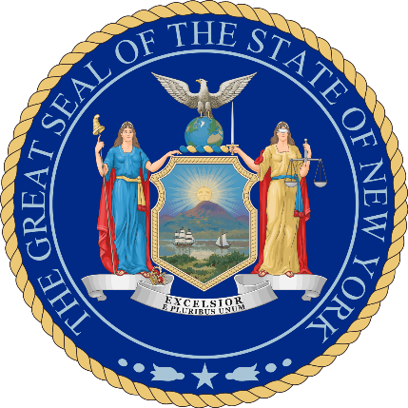**Branches of Government in New York State**

Legislative Branch:

**1. What is the main power of the legislative branch?**

To make laws

**2. What are the two houses which comprise the legislative branch?**

* Executive branch

* Judicial branch

**3. After a bill is passed in both houses of the NYS Legislature, who is it sent to for his/her signature or veto?**

The governor

**4. How can the NYS Senate and NYS Assembly override a governor’s veto?**

2/3 agreement in each house can override the governor’s veto

Executive Branch:

**5. Who is the head of the executive branch in New York state?**

The governor

**6. Identify three of their main duties:**

* Submit a yearly State Budget to the Legislative

* Sign or veto Legislative bills

* Convene the Legislature for special sessions

**7. What are the main duties of the Lieutenant Governor?**

Serve as President of the State Senate, assumes the governorship in case of impeachment, resignation, absence or death of the Governor

**8. What is the job of the State Comptroller?**

Serves as the administrative head of the Department of Audit and Control.

**9. What is the job of the State Attorney General?**

Heads the Department of Law and is responsible for the prosecution of all actions for or against the State and for the legal affairs of state officers and departments.

Judicial Branch:

**10. What is the state’s highest court?**

The Court of Appeals

**11. Identify three types of cases which could be heard in state courts?**

* Provide legal protection for children

* Determine the legality of wills

* Criminal charges

**Making Connections:**

***In what ways is the structure and function of New York State government similar to the Federal Government? How is state government similar to local government?***

New York State and the federal government have three branches of government. The executive branch, legislative branch and judicial branch. State government is similar to local government since they also have three branches of government.